**Data Analysis of Netflix Dataset using Tableau**

Netflix is an American over-the-top content platform and production company. It was founded in 1997. Netflix is available worldwide except in: Mainland China, Syria, North Korea and Crimea.

Initially, Netflix business model included DVD Sales and rental by mail. In 2007, Netflix expanded its business with the introduction of streaming media, while retaining the DVD and Blu-ray rental business.

Netflix entered the content-production industry in 2013 with its first series "House of Cards".

Since 2012, Netflix took more of an active role as producer and distributor for Movies and TV Shows and also offer "Netflix Original" content through its vast online library.

During the worldwide COVID-19 pandemic in 2020, Netflix acquired 16 million new subscribers.

**Amount of Content Added over the years on Netflix**

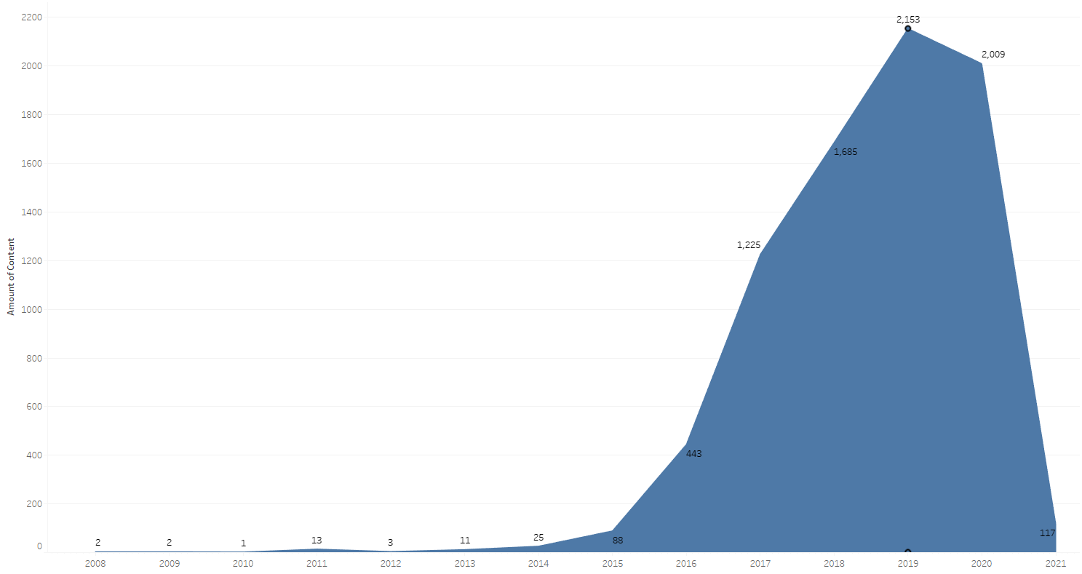

There is a significance growth of content added over the years since the streaming service started with 2019 being the year where the most content was added. 2020 was a close second. It can be assumed that due to the COVID-19 pandemic, since a lot of movie and show releases were delayed and hence were not released in 2020, there was some decline in the amount of content added.

**Amount of Content by their Released Year on Netflix**

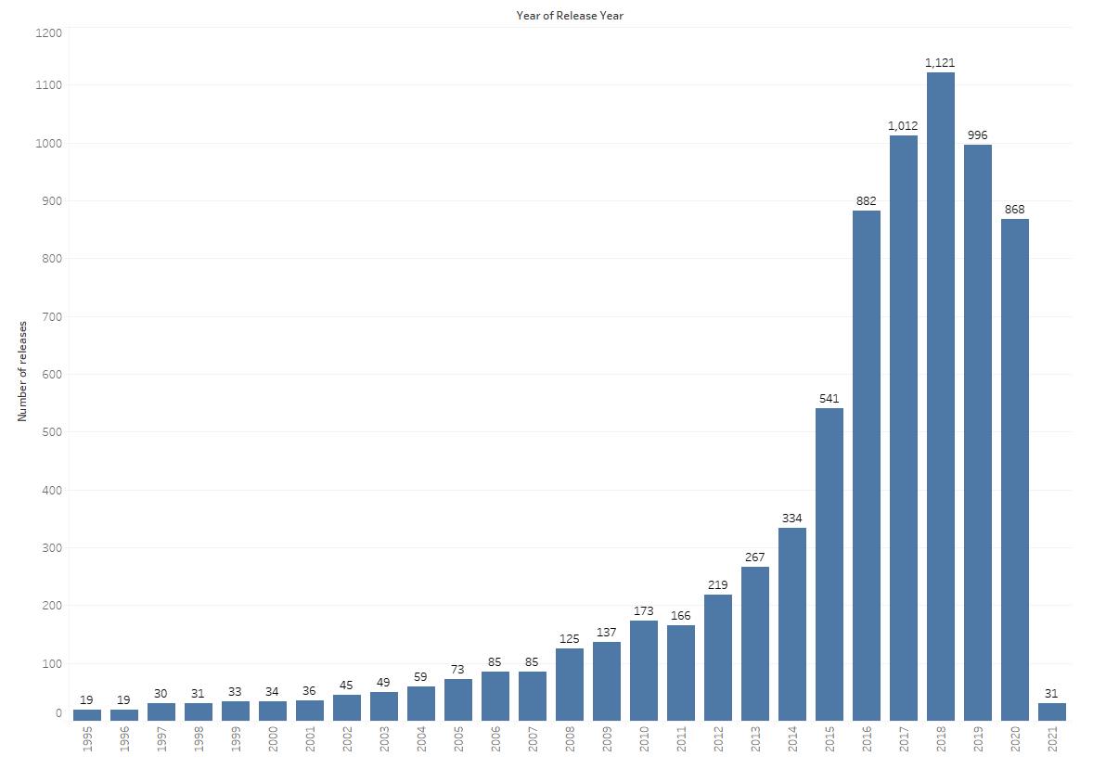

The most amount of content on Netflix was released in the year 2018, followed by 2017 and then 2019.

**Movie/TV Distribution on Netflix**

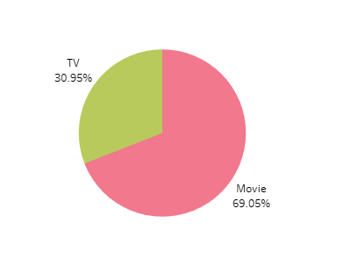

69% of the content on Netflix are movies, whereas only 31% of their content are TV shows.

**Movie Rating Distribution**

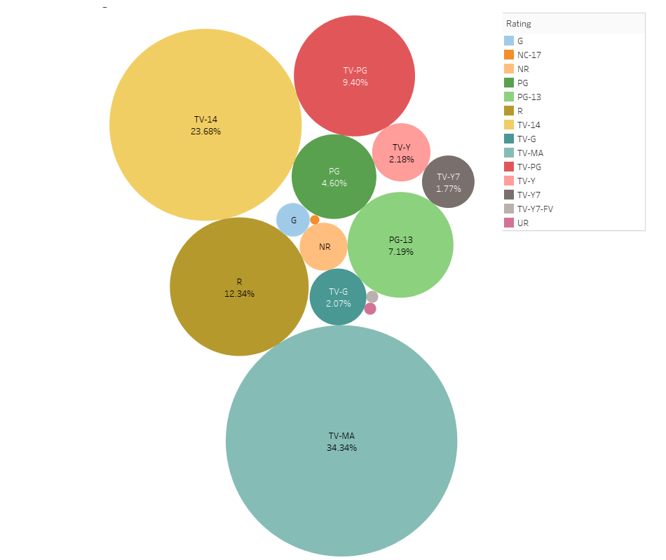

Majority of the movies on Netflix are for Mature Audiences, or content that needs to be watched with Parental Guidance (TV-14)

**TV Rating Distribution**

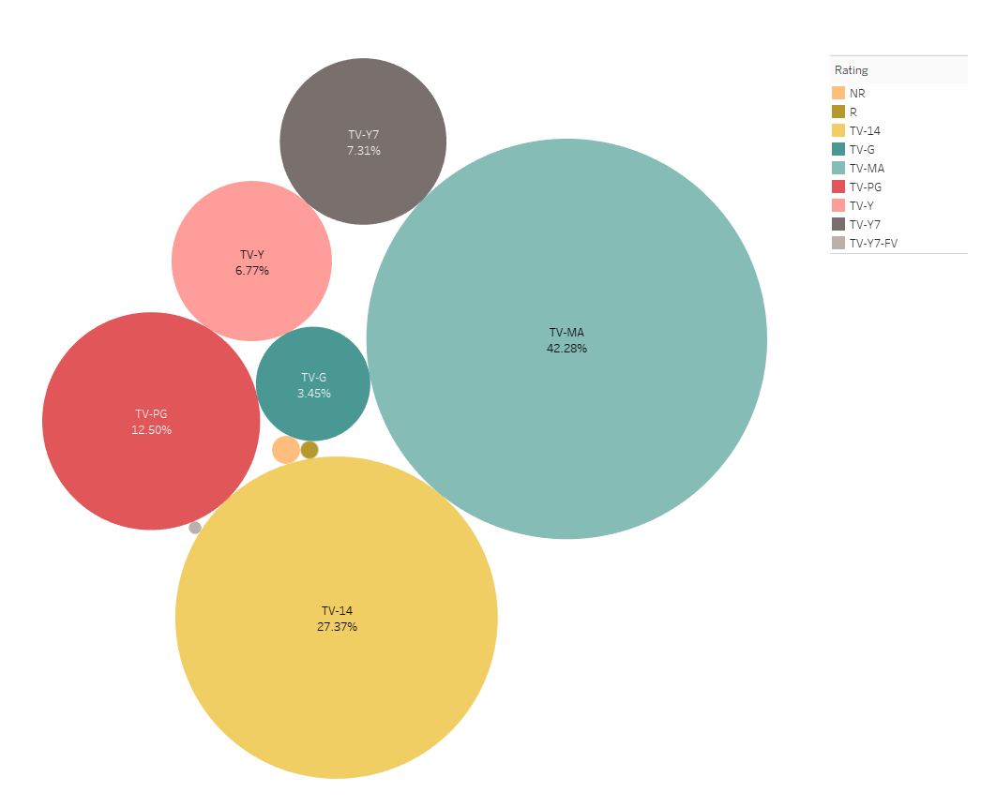

Just like movies, majority of the shows on Netflix are for Mature Audiences, or content that needs to be watched with Parental Guidance (TV-14)

**Country Word Cloud**

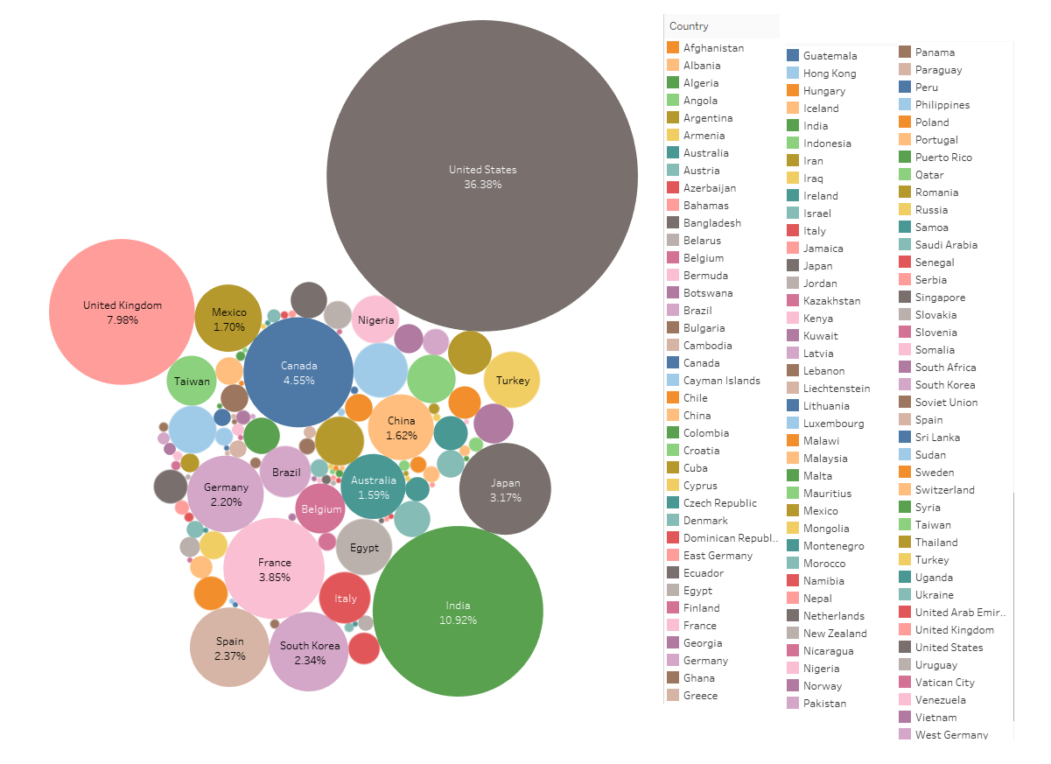

United States owns the most content on Netflix, followed by India and then United Kingdom

**Genre Word Cloud**

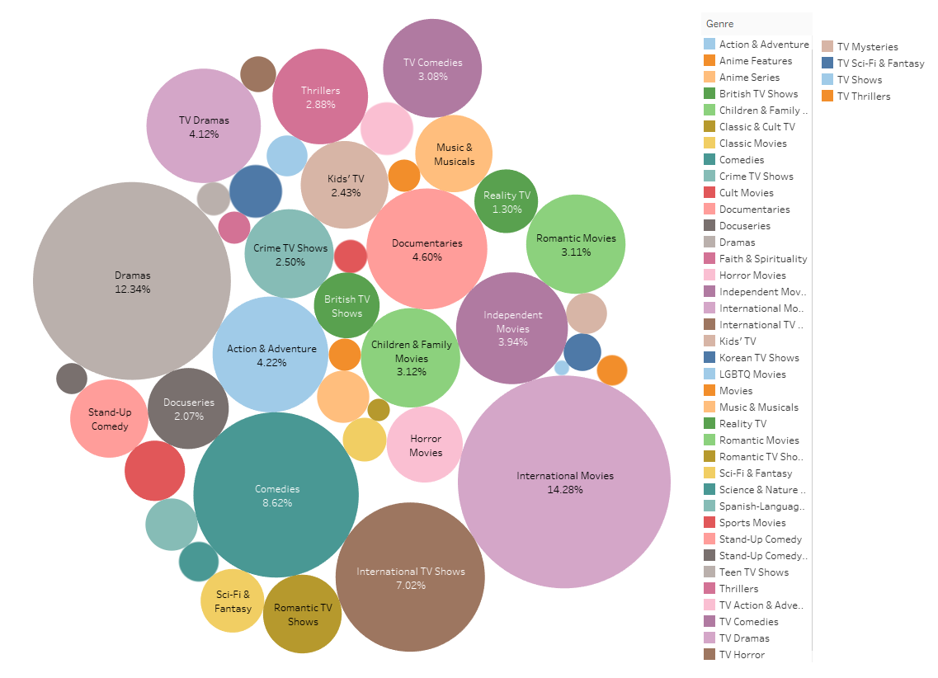

**Releases on Netflix throughout the Years**

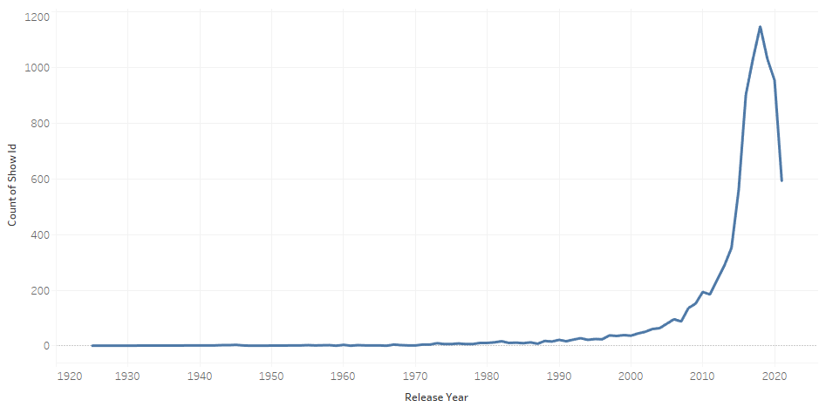

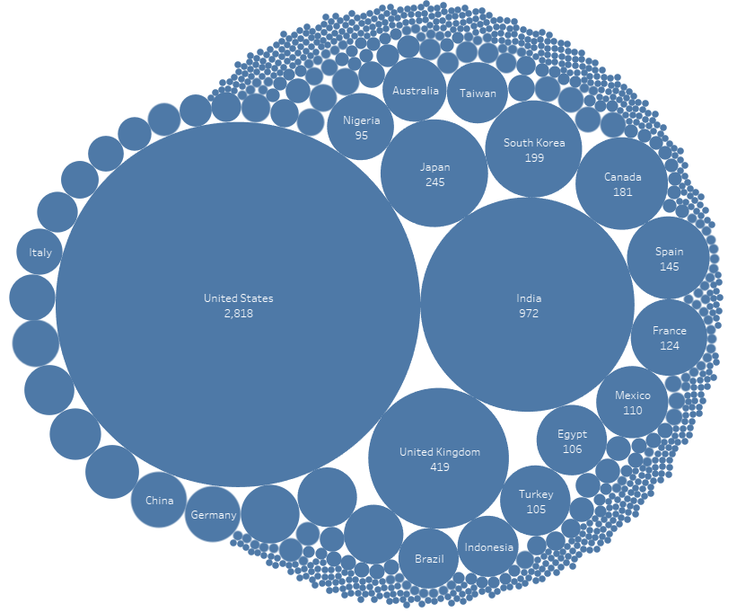

* Netflix began as a company that sold and rented DVDs via mail at first. Netflix launched streaming media and video on demand in 2007.
* Netflix started streaming current and past movies and tv shows. Dated as early as 1925
* In 2013, Netflix entered into content-production industry by producing their first show. House of cards. After 2013 netflix saw a huge boom in original programming development.

Netflix has an umpteen amount of content belonging to different genres. The genre that the most content is international movies. 14.28% of the content on Netflix is listed in the international movies genre.

Entered international production in 2017 with their first Columbian series. Netflix Entered india very late in the year 2018 with their first produced content, but they grew rapidly in india. Producing 900 plus series/tv shows in just 3 years

United States owns the most content on Netflix, followed by India and then United Kingdom

There is a significance growth of content added over the years since the streaming service started with 2019 being the year where the most content was added. 2020 was a close second. It can be assumed that due to the COVID-19 pandemic, since a lot of movie and show releases were delayed and hence were not released in 2020, there was some decline in the amount of content added.

Evolution of Netflix

Netflix is an inspiring example of a firm that has successfully modified its business model numerous times and grown massively as a result. They began by renting products through mail across the United States, then moved on to providing on-demand entertainment to meet a variety of requirements around the world. Netflix's subscription allows you to watch your favourite shows whenever and wherever you choose.

It all started in 1998, Netflix began mailing DVD rentals. Netflix switched from a pay per use to a subscription model a year later. Netflix converted its offering to a streaming service about a decade later. Although newcomers like as Amazon Prime, Disney plus have entered the market, Netflix remains the industry leader, with 200 million plus subscribers.

Netflix began streaming current and previous movies and television shows some released as early as 1925. They produced their debut show in 2013, marking their entry into the content-production market. The game House of Cards. Following 2013, Netflix experienced a significant increase in original programming development. Not only did Netflix started streaming multiple tv shows and movies after 2013, they also started producing original content quickly. After 2013, Netflix saw immense growth.

Netflix provides an abundance of content from a variety of genres. International films are the genre with the most content. The international movies genre accounts for 14.28 percent of Netflix programming. Followed by drama and comedy which account for 12.34 percent and 8.62 percent respectively. International Tv shows accounts for 7 percent of the content on Netflix.

In 2017, they made their worldwide debut with their first Columbian series. Netflix arrived in India, in 2018, with their first created content, but they grew very rapidly in India. In just three years, Netflix produced over 900 series and television shows in India. Netflix has managed to make major inroads into the market. As Netflix was founded in the United States of America, most of the content on Netflix is owned by USA. On the second place we have India, despite the fact that Netflix entered the Indian media streaming service market very late, it has grown exponentially there, giving very tough competition to an already established media streaming giant, Amazon Prime.

Since the streaming service first began, there has been a significant increase in the amount of content added in it, with 2019 being the year where the most content added was added on Netflix. 2020 came in second place. The amount of content added is likely to have decreased in the past few years as a result of the COVID-19 pandemic, as many movie and show releases and production was delayed, hence causing the recent decline.